NG Tubes for Beginners October 2005

We’ve started seeing new grad nurses in the MICU in recent years, and it’s seemed that they might need a hand with some of the basic tools – things that in times past they might’ve spent time working with on the floors, but which now they have to get a faster grip on, since they’ve come straight into the higher-acuity area. This is our first is a possible series – topics we have in mind: “The ins out outs of Foley catheters” (sheesh!), “Peripheral IVs for beginners”, “Which IV Fluid Should My Patient Be Getting?”, “Admitting Your Patient to the Unit”… things like that. Let us know what you think of this one, and as usual, please remember that these articles are not meant to be the final word on anything – always refer to your own policies and procedures, and let us know when you find errors. Thanks!

A couple of cool things: if you’re interested, you can follow up on the image and reference links – that’s the blue web address lines in this article, simply by clicking on them. If you’re reading this article from our website, you’ll go directly to the source of the image, or the quote.

The second thing is that the images in these articles can be enlarged. Click the image, grab a corner with the mouse, and drag – bada bing! Big picture! Cool! Helpful with the x-rays.

- What is a nasogastric tube?
- What is an orogastric tube?
- What is a g-tube? PEG tube?
- What are Salem sumps all about? What’s a sump?
- What is an enteroflex tube? Dobhoff tube?
- What’s a j-tube?
- Who inserts gastric tubes?
- How do I insert a gastric tube?
- How do I assess the placement of the tube? Two really important points.
- How do I secure these tubes to the patient?
- How do I check a gastric aspirate with a Salem sump? Another really important point. A quick story. And about Lopez valves…
- With an enteroflex?
- With a dobhoff?
- How much aspirate should I refeed?
- What can go wrong with a feeding tube?
  - It can go into the wrong place.
  - Coiling
  - Too shallow
  - Too deep
- While it’s in?
- If it gets pulled out?
- If it gets plugged?
- Should these tubes be routinely changed?

1- What is a nasogastric tube?

I think in one of the other articles, we made the point that there are certain professions that require constant examination of all the things you do – I think the example was piloting aircraft. Pilots are forever refining, evaluating, and adjusting their techniques, so that apparently you’ll see big arguments break out amongst them about how apparently small things should be done: setting flaps, when to retract gear, whatever it is they’re doing, they’re always thinking about how it should be done, regardless if it’s apparent importance.

This is a good attitude to take into the ICU. There are always things that need thinking about – always things that need to be evaluated – devices or procedures that seem elementary actually aren’t… and even the “simplest” device can get you or your patient into serious trouble unless you’ve taken the time to understand it, and assess it, and use it properly.

Peripheral IVs are a good example – did you check to make sure that the line has a good blood return? Are you sure that your patient is getting the med running through the line? We had a lady recently whose peripheral neo mix infiltrated… yow!

So – NG tubes are another good example of a device that seems totally simple and uncomplicated, but which actually… well, let’s see.

Naso-gastric: through the nose, into the stomach.
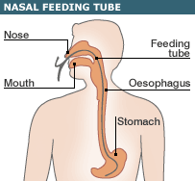

Here it is… “oesophagus”?

http://www.tomwalsham.com/News/4396273.stm_files/_40978923_nasal_tube_inf203.gif

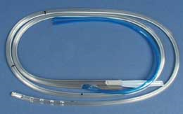

The most common of the nasogastric tubes – the Salem sump. These are large-bore, usually 14 or 18 French, and fairly stiff…

http://www.progressivemed.com/emsproducts/airway/salem_sump.htm



This is the softer variety – the ones we use are called “enteroflex” tubes. There’s a longer version that goes the same route, but ends up in the duodenum, past the pylorus – that’s the “dobhoff”.

“Look, she’s smiling!” – “Nah, it’s just gas…”

http://www.msteechur.com/ngstrip.jpg

2- What is an orogastric tube?
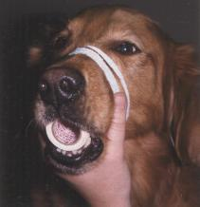
Not too hard – through the mouth, into the stomach.

Guys? I think it’s coiled in the mouth…

Nasogastric tubes are painful and uncomfortable, and apparently they cause sinusitis, so our intubated patients get their gastric tubes put in orally.

http://www.cvm.umn.edu/academics/course_web/current/ClinSkill_3/Orogastric/Images/Pic_1_6T.jpg

3- What is a g-tube? PEG tube?

This time it goes through the wall of the stomach, instead of down the oesophagus. “Percutaneous endoscopic gastrotomy” – “PEG tube”.
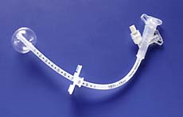

The flat part is sutured to the abdominal wall, and the part with the balloon lives inside the stomach. This one is made of silicone plastic – very nice and soft, doesn’t get eaten up by gastric acid, and can stay in place for a long time.

http://www.gatestone.net/photo/g-tube.jpg

4- What are Salem sumps all about? What is a sump?

This is the clear-and-blue tube a couple of pictures back. These guys are actually two tubes in one – and for a smart reason. Back in the day, nasogastric tubes with a single lumen were the only option – the only ones I saw, anyhow. I think they were just starting to go away when Jayne and I were in school, back in the late 70’s. Right around the time of the gold rush. Anyhow – one tube – what’s the problem?

The problem is – you hook this thing up to suction, right? Ok – drains the stomach, all fine and good. What happens when the stomach is empty?

Hm – well… stomach’s empty, but there’s still suction on… well, the tube can either suck up against the stomach wall somewhere – maybe not so good. Or – it can start sucking the air out of the stomach, which is ok up to a point, but when it starts collapsing the stomach… hm – not so good.

Well then, how about this: let’s add a second lumen to the tube, so that when the stomach is empty, the second tube will let air come back into the stomach, which won’t get sucked all tiny, and which also – hopefully - will prevent the tube from sucking up against the stomach wall. Cool!
That’s a “sump”. The second lumen – what some people call the “pigtail” – lets air come back into the stomach. Neat!

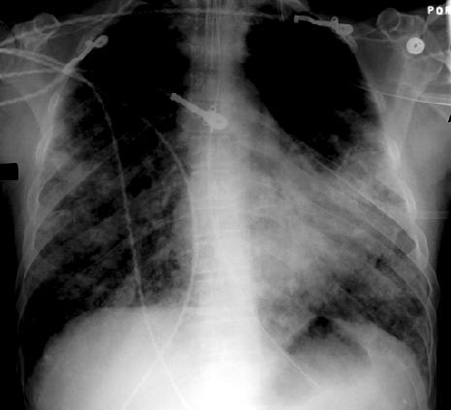
Reading x-rays isn’t easy, but there’s an NG/OG tube in this one, and you should have some kind of idea of how to find it. I’ve played around with the contrast of the image to make it a bit easier to find, but you’re looking for something that’s:

- not a chest wire

- that goes down the center of the chest

- that ends somewhere in the stomach….

http://www.vh.org

5- What is an enteroflex tube? Dobhoff tube?

These are the softer tubes, like the one Bubbie has in her nose a page or two back. They’re much more easily tolerated once they’re in, and they’re definitely the ones I want. A big problem however is that you can’t reliably empty the patients’ stomach through them. This really matters – if your patients’ gut isn’t moving things along properly, and he has, say, a liter of fluid in his stomach – he’s at an enormous aspiration risk. Yup – even if he’s intubated, with the ET tube cuff inflated.

These tubes usually have a sheathed lead weight at the end, which helps them float along into position.

http://www.uam.es/departamentos/medicina/anesnet/journals/ija/vol4n2/feed2.jpg
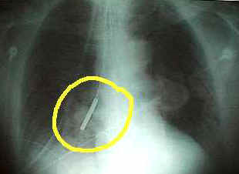

See the weight? Hmm… wait a second…
Not a chest electrode… ok. Down the middle of the chest… hm. Ending up in the stomach… uh…

Well guys? Where’d this one go? Think maybe we ought to take it out?

6- What is a j-tube?

Some patients are at risk for aspirating over and over – it turns out for example, that recurrent GERD – y’know? – acid reflux disease? – can make the lower esophageal sphincter quit working. “Esophageal sphincter incompetence.” Not a happy thing – can be a deadly thing. Why?

What to do?

Well – there’s a pyloric valve at the bottom of the stomach, right? Hm… if we deliver the tube feeds beyond the pyloric valve… maybe the patient won’t aspirate! Woohoo! Time for a Dobhoff tube.

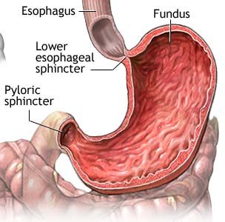

The Dobhoffs are the longer version of the soft feeding tubes, also with a weight at the end. They pass down the oesophagus, through the stomach,

past the pylorus,

and the end winds up in the jejunum.

http://medicalimages.allrefer.com/large/stomach.jpg

It’s a good idea, anyhow… I’m not too sure how well it works in practice. People secrete stomach fluids all the time – so what you’ll see sometimes is an NG tube to suction, and a J-tube for feeding. Complicated. The feeds have to be “elemental”, or “predigested”, so it’s usually something like Vivonex.

7- Who inserts gastric tubes?

At our institution, the nurses put in nasal and oral Salem sumps. The smaller feeding tubes have to be put in by physicians. These decisions, about who gets to do what, are probably made by hospital risk-management committees, working with the insurance companies who provide liability coverage to the hospitals. So don’t feel bad if they don’t let you place them and make the docs do it. ☺

8- How do I insert a gastric tube?

Carefully! There are lots of descriptions out there on how to do this, and instead of replicating them, we’ll just make some comments:

First, as always: make sure the patient consents! Things are a bit simpler when your patient is sedate, because then consent is usually implied, but you still have to be clear that consent for procedures has been given, either by the patient beforehand, or by a proxy. It’s worth mentioning that emergency consents for procedures are implied when a patient comes in unconscious, with no family members – every now and then we get an “Unknown White Male”, who wakes up and tells us who he is… but the consents still need to be made out and signed by physicians – use the usual forms for blood and procedures.

Next: think about what else is going on with this patient. Does the patient have a history of nosebleeds? Is she anticoagulated? Got platelets? Varices? Just had variceal bands applied? Yup, you have to think of all these things… a patient with recent bands? No way am I inserting that tube – that’s why the Great Nursing Supervisor invented GI docs.

Then: you want to make sure you’re inserting the tube to a reasonable depth. Measure one way or the other – match the length of the tube from the patient’s big toe to her earlobe, subtract pi*R squared, add her shoe size in centimeters times the chi-square regression… hey! Do I get my masters’ now? The tube has to go in far enough to drain the pool that should be there in the patient’s stomach.

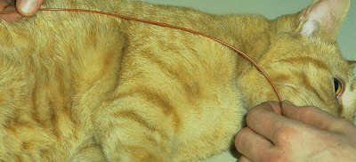

Um… far enough?

http://courses.vetmed.wsu.edu/samdx/nasogastric_tube.asp

Now pick your approach. Nasal? Oral? Does the patient have a history of nosebleeds?

Lots of lubricant. Sometimes I like to wrap the end of the tube around my (gloved) hand for about a minute to help form the curve that will pass through the patients nose.

Pass the tube slowly – and don’t force it! You do have to use some forward pressure – experience will teach you how much. Get someone to help you.

Here’s a critical trick: as the tube goes in, put the other end of the NG tube to your ear and listen. If the tube is patent, and it ought to be, then if you’re approaching the airway, you should hear – what? Breathing? Good guess! Don’t advance!

To help the patient swallow the tube, have some crushed ice at hand and give him a little, orally. Or use a saline fish.

Have your gastric suction line at hand. No higher than what – 80mm of negative pressure? Have the little connector gatsy attached – when you get to what seems like reasonable depth, hook up the line, see what comes out. Stomach contents? Good job! Are you sure the tube is deep enough? You can get gastric contents from the upper part of the stomach…

9- How do I assess the placement of the tube? Two really important points.

Good question. The traditional way of doing this is to attach the hugeous syringe, and quickly push 30cc of air into the tube, while listening over the stomach with a stethoscope. People put the scope bell over the stomach, usually just below the patient’s diaphragm, at the midline, and somebody pushes in the air, and people hear a nice woosh, and everybody nods and says: “Perfect!”

Well… it’s not always that easy. Sometimes gastric tubes will go to strange places – there are only a couple of places they should be able to go, but very unpleasant and weird things have happened. Want to know?

- “…insertion of a nasogastric (stomach suction) tube through the ethmoid bone of the skull during surgery, causing parts of the patient's brain to be sucked out and causing his death.”
http://www.bobtoth.com/anesthesia.html

Whoa. Does that mean that you should push in the air, and listen with the stethoscope on top of the patient’s head? Just to make sure? Hmm… “Well, I was just making sure!”
Yeah, that’ll look good ☺.

Similarly:

- “When a fracture of the skull base is suspected, insertion of a nasogastric tube (NGT) should be avoided. The orogastric route is preferred as there have been cases of intracranial NGT placement in the presence of cribriform plate fractures.
”http://www.sbiheadlines.com/research/papers/Craniofacial%20and%20Skull%20Base%20Trauma.doc

Remember this one? What kind of tube is it? Where’d it go?

The scary part is that you can hear a nice “woosh”, even if the tube is in the wrong place…

http://www.uam.es/departamentos/medicina/anesnet/journals/ija/vol4n2/feed2.jpg

So… what do Jayne and Mark say? First off - don’t force the tube! Second, assess the patient while you’re placing the tube! Third – if you have any questions at all about the placement of the tube – the standard of care is to get an x-ray.

If I hear a woosh, (over the stomach!) but I don’t get gastric contents, I ask for a film. No exceptions.

A second critically important point: Once the tube is in, and you know it’s in the right place: hook it up to suction, and empty the patient’s stomach. I always, always do this. If that patient has a liter and a half in her stomach, you want it out of there! How much does she need to aspirate to get pneumonia? Or ARDS? Yes, you will find people, as always, who disagree with this… I don’t care! ☺

10- How do I secure these tubes to the patient?

For nasogastric tubes, a little benzoin to the skin, and a piece of cloth tape, split, with the splits around the tube (flag the ends so you can get em off later), and the fat end on the patient’s nose. Or a tegaderm, which I like better – softer…

For orogastric tubes, almost always for intubated patients, we tape them to the ETT tube, a couple of inches away from the mouth. Cloth tape, flagged.

I am not a fan of using safety pins to pin things to robes/ shirts/ johnnies. What if the patient pulls his shirt off?

11- How do I check a gastric aspirate with a Salem sump? Another really important point. A quick story. And about Lopez valves…

Well – why are you checking the gastric aspirate at all? It’s very important – you don’t want to let a whole lot of fluid collect in the patient’s stomach, so that:

- what doesn’t happen?

- and why might that happen?

- and so what else would you want to assess besides the gastric aspirate? And what else?

- uh huh, and what if there aren’t any?

- well, why wouldn’t there be any?

- and what med do we use all the time that makes this happen?

- so what should you do about it?

a- Aspiration. b- Because the patient has too much in his stomach! c- Bowel sounds. And stooling. d- Uh… there might be a problem? e- Um…recent surgery? Paralyitc ileus? Gastro-intestinal hypomotility? f- Fentanyl g- get the patient started on a bowel regimen, possibly including colace, senna, IV reglan, po narcan…

Well anyhow – it’s incredibly important to check the aspirate, and to try and prevent aspiration events.

Here’s a quick story: I’m the nurse in charge one night, running around, checking the hot spots, helping out, stuff like this. Nurse comes to me, says: “Well, my patient keeps vomiting.”

Me: “Um, isn’t he intubated?” Meaning, doesn’t he also have an OG tube? And if he’s vomiting, isn’t it hooked up to suction?

Nurse: “Yeah, and I don’t know why he keeps vomiting – I mean, I irrigated the OG tube and all…”

We went to take a look. And here we get to the point. OG tubes do not automatically drain a patient’s stomach, just because they’re apparently at the right depth. Bummer.

Yup, it’s true. What a pain. You can hook a Salem sump to low wall suction, and it may very well not work. Mainly, this is because the tip of the tube gets stuck somewhere – maybe it’s coiled up in the patient’s stomach folds, maybe the tip has coiled up into the antrum, above the pool… or maybe one or both of the lumens is plugged – if the main lumen is plugged, then the drainage is going to try to come out through the pigtail.

Remember the pigtail?

Here’s what you want to see: with the Salem sump hooked up to suction, the stomach will be empty when the pigtail starts whistling. Make sense? All the fluid inside the stomach comes out- what’s left? Air? So now what happens? Air starts coming in through the pigtail – it whistles. Now you know – if the tube is in at the right depth – that the patient’s stomach is empty.

What if the pigtail won’t whistle?

Here’s what to do: Irrigate the lumens. Still not draining? Undo the tapes holding the tube in place. Pull the tube back a bit – an inch or so. Or advance it a bit – an inch or so. Draining now? Whoa…. eek! Did you just get a liter out? Good thing!

So – if your pigtail is draining, should you clamp it with a Kelly? Tie it in a knot?

Do this assessment every four hours!

Oh yeah – the other thing. Seen these things?

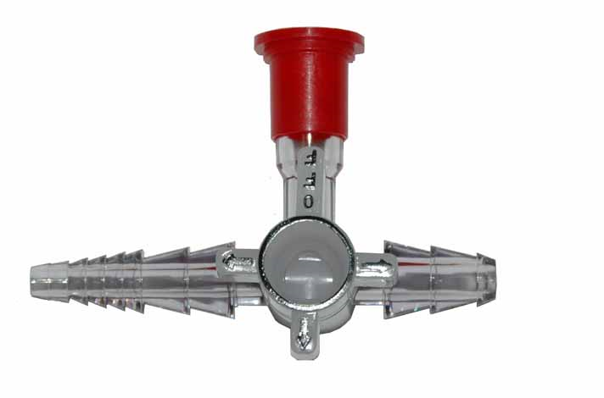
Lopez valves. We use them to give meds through feeding tubes, so we don’t have to disconnect the tube feed setup every time. The thing is – if you decide to drain your patient’s stomach by hooking up the suction to the valve here where the red cap goes – well, you can see how tiny the left-side end is, right? Very easily plugged. This means that suction to drain the stomach may not work if it’s run through the valve.

So – if you’re worried, take the valve out. Use a regular barrel connector, then hook up the suction.

http://www.palmedical.co.jp/lopez/lopez-1.jpg

12- With an enteroflex?

You can’t. Or maybe you can, a little – but not reliably. Sometimes you get lucky – but in general, you can’t really aspirate through the little feeding tubes, because they’re so soft, and their size is so small, that they just collapse when you try to use negative pressure on them.

This came up just last week. Guy had had reconstructive surgery for his oral cancer – partial tongue resection, jaw flap, donor sites, this and that, lube, oil, filter… and then postop… well – why do people get oral cancer? From doing what? And drinking what? And so what are they at risk for when they come into the hospital, and can’t get it? Right!

So – he DT’ed. Pulled out his hemovacs – apparently it was ugly. Went back to the OR I think, reintubated, got the hemovacs replaced, straightened out, and then got sent to us for management of the DT’s. Started on versed, and fentanyl. Nasal enteroflex tube. Tube feeds…

Well – see? This is a dangerous NG tube situation. Here’s a fellow getting all sorts of sedation – I come on, it’s day two in the ICU, tube feeds are at 40cc/hour. No bowel sounds, hasn’t stooled since coming to the ICU – well, he’s on fentanyl. Yeah, he’s tolerant to the benzos probably, because why? Right! But is he tolerant of the fentanyl? Nooo, he is not! So what happens to his gut? So… why does it become really important that I know how much is in his stomach?

We explained this to the ENT surgeon when he came in – his response: “Well, is he absorbing the tube feeds?” Us: “We can’t tell.” Resident: “Why not?” Us: sigh…

I mean – it might’ve been just fine – no problem at all. But you don’t really know for sure – and you really do need to.

13- With a Dobhoff?

Think about this for a second. Where is the end of this tube – that is, where is it supposed to be? Uh huh… and can you expect to aspirate much from there? And through a soft tube, at that?

14- How much aspirate should I refeed?

Well – you can always find a policy for everything – and that’s right, you should be able to find some kind of official guidance for your practice. We have a policy that says to refeed all amounts aspirated up to something like 200cc. I don’t like it. I think the policy should say: “Refeed all aspirates up to something like 200cc, but only if the patient has active bowel sounds, if they’re stooling regularly, and clearly aren’t having aspiration events.”

(Maybe it does say that… hmm… been a while since I read those. Think it’s easy to find them in those enormous folders? A request: please, please, please, can we have all hospital nursing policies made available on the hospital computer network, in searchable, indexed, printable form? Please? This should’ve happened a long time ago!)

15- What can go wrong with a feeding tube?

It can go into the wrong place: the tube can coil up into the mouth (if you’re placing it through the nose – I’ve never heard of one going up and coming out of the nose during oral placement – although life is always full of new things!) Or, as above, it can go into the airway, through a bronchial wall, and out into the lung tissue. Or into the head. Bummer.

It can be placed too shallowly. With the tip in the esophagus. Why would this be a problem for someone lying in bed? Why should everyone on bedrest be kept at least 30 degrees head-up at all times?

It can go too far in. Sometimes the end of a Salem sump can make its way into the duodenum, and if you’re trying to keep your patient’s stomach empty, it’s not going to work.

Actually, this can produce unexpected results: a couple of times over the years, I’ve seen Salems to suction, and the nurse ahead of me will comment on how much drainage the patient is putting out – liters and liters, usually some unusual color, like orangeade… the tube is too far in. Take a look at the film with the team. Where’s the tip? Leaving the tube to suction, pull the tube back some… did the drainage suddenly change color? How come?

The soft feeding tubes are inserted with a fairly stiff wire stylet in them, that comes out after the tube placement is confirmed. What could that stylet do?
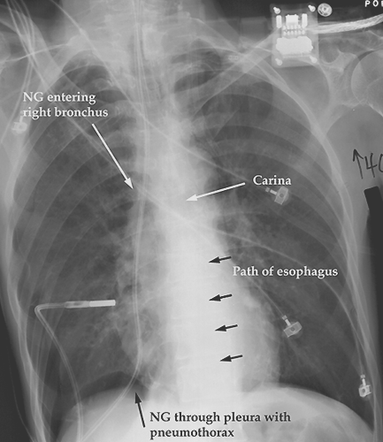

Whoa!

http://www.vh.org

16- While it’s in?

Stomachs sometimes get erosion injuries from the stiffer tubes, so Salem sumps don’t usually stay in much longer than a week.

Oesophaguses also.

What if the tip of the tube gets pulled back up into the esophagus? And your patient is lying flat in bed?

What if the patient has varices?

Question for thought – what if the patient has a trach? Should that patient have a Salem sump in for a long time? What might happen to the tissue between the trach tube and the Salem tube? What is a tracheo-esophageal fistula?

17- If it gets pulled out?

Well – it’s not very nice if the tube has to be replaced several times. And as above, what if it gets pulled back only part way? What if the tip got pulled back, say, to the pharynx?

18- If it gets plugged?

Every nurse has her own trick for unplugging a stuck gastric tube. It often has to do with what the tube is plugged with – is it some pill that wasn’t crushed up well enough? Some people like ginger ale, some people like hot cranberry juice, some people like hot water – just be sure it’s not too hot! Some people like papain, but that’s the stuff that you use to dissolve something made of protein, so it probably won’t work on a little plug of carafate that’s stuck in the tube. Make it a practice to crush up your meds pretty well, and try letting them dissolve some after crushing as well, in some warm water.

Remember that some meds are NOT meant for NG tubes! Any preparation of sustained release anything is not supposed to be crushed up and squirted through a tube! If some silly doc writes a po order for an SR med without realizing that the patient hasn’t swallowed a pill in two weeks… straighten her out!

19- Should these tubes be routinely changed?

In practice we don’t usually do this unless the tube is plugged and can’t be cleared, or unless we’re changing the patient from a Salem to one of the soft tubes. Anybody know how long a soft feeding tube can stay in?

